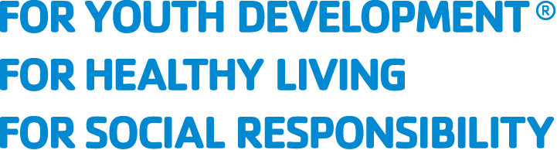
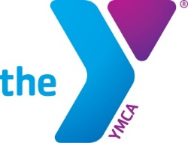

Board Member Application
Thank you for your interest in joining the Duluth Area Family YMCA’s Board of Directors. The Board seeks to elect new members at the December 13, 2022 board meeting. We encourage all interested candidates to apply. Areas where the board desires increased representation include:

- Age (40 or younger)
- Geography (Carlton County, Koochiching County, Grand Portage Band of Lake Superior Chippewa, Bois Forte Band of Chippewa, East Range communities)
- Ethnicity (BIPOC individuals)
No prior board experience is required. Newly elected board members will begin their terms in January of 2023, and must be able to attend meetings in-person, each month.

Applications must be completed online or delivered to the Downtown YMCA (302 West 1st Street) by October 24, 2022.
All applications will be reviewed by a committee including YMCA board members and staff. This committee will interview select candidates.
Before filling out the application, please read the Board Member Position Description. A link to the application is available on the home page of our website.

To help you prepare responses, the application questions are as follows:

Name (first and last), Address (Street, City, State, Zip Code), Email Address
Telephone number where you can be reached during the day
What is your age?
Please describe your race/ethnicity
What is your gender?
What is your occupation?

- What makes the YMCA’s mission meaningful to you?

- What experience do you have--personal or professional--that is related to our mission?

- Give an example of how you represent one the YMCA’s core values: (Caring, Honesty, Respect, Responsibility).

- What skills, perspectives, and life experiences will you bring the board?

- Describe any relationships and/or resources that could bring value to our organization.

- How did you hear about this opportunity? Select all that apply.
- Social Media (Facebook, Twitter, etc.)
- Referral from current member
- Other referral

Please include your resume when submitting this application. Applications can be submitted to:

BoardApplications@duluthymca.org

Or delivered to:

Duluth Area Family YMCA
302 w 1st ST
Duluth, MN 55802

Please email with questions:
Barbara Jutila, Senior Administrative Specialist bjutila@duluthymca.org

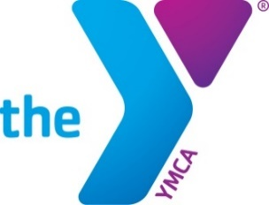

Board Member Position Description
The YMCA is a 501(c)(3) public foundation established in 1870.

Mission:
The Duluth Area Family YMCA is dedicated to putting the principles of caring, honesty, respect, and responsibility into practice through programs that build healthy mind, body, and spirit for all.

Responsibilities:
- Fiduciary - Approve annual budget, investment strategy, large grants, loans, and audits. Make sure funding and programs are in alignment with mission. Review financial statements and monitor fiscal controls. Assist with annual fundraising efforts and events.
- Strategic - Develop and monitor mission and strategic plan. Refresh from time to time. Hire, support, and assess performance of the President & CEO. Establish policies and goals to ensure accountability to the law and our values. Identify, recruit, and elect members. Create connections throughout the community.
- Generative – Bring personal and professional expertise to support the mission. Engage in deeper inquiry, exploring root causes, values, options, and new ideas for the organization.

Expectations:
- Support the YMCA’s mission.
- Understand the YMCA’s organization and policies and abide by them.
- Participate in board meetings and sub-committees.
- Attend events and site visits.
- Make a meaningful annual financial contribution—no established minimum.
- Serve as an ambassador both in communicating out and gathering feedback of our work.
- Assist with fundraising and friendraising.

Time Commitment:
  - Members may serve up to two consecutive three-year terms.
  - The Board of Directors meet in-person on the second Tuesday of each month from 3:30 – 5:00 PM.
  - Board members may serve on sub-committees.
  - Outside of committee and board meetings, board members are expected to attend YMCA events. This may include site visits, fundraising events, program celebrations, or trainings.

